**CONNECTING DATA**

**Connect to the Store Sales Data and do the following: -**

* Remove all the blank rows.
* Update the column header if they are not updated

**− Create a text table and show the sales in terms of**

* Customers
* Product Category
* Regions

**• Create a line and Clustered Column Chart showing the Sales and Discount as per**

**the State or Province**

* Format the bars and line with different colors
* Which state has the highest sales in terms Technology

**New York has the Highest Sales in term of Technology**

• **Create a Donut Chart showing sales in terms of Product category**

**• Create a Slicer and show the regions in dropdown. See how all the visuals**

**mentioned above behaving when a particular region is selected.**

**All Regions: -**

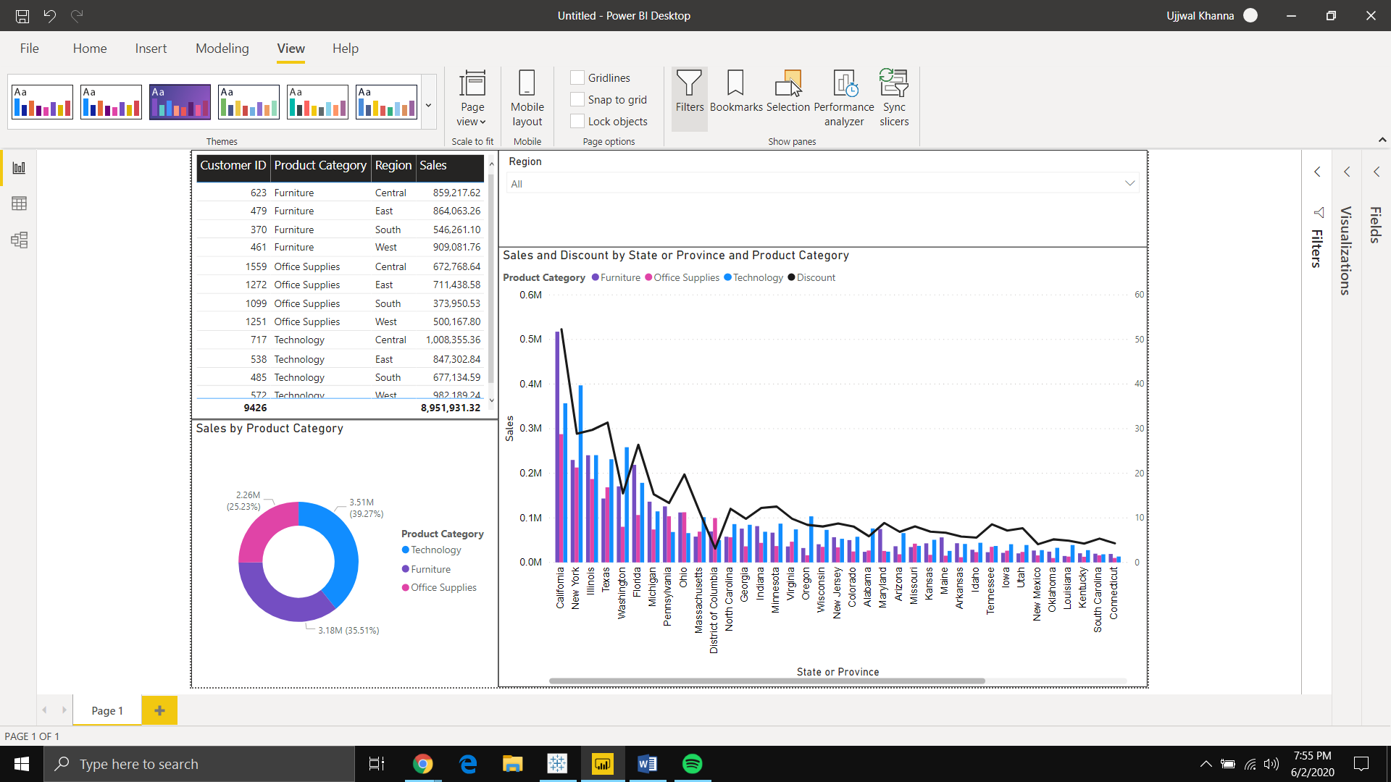

**Central: -**

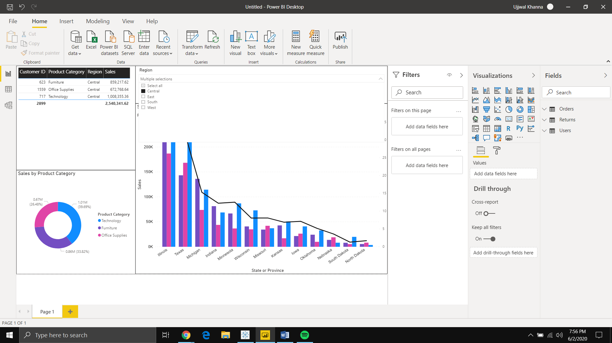

**East: -**

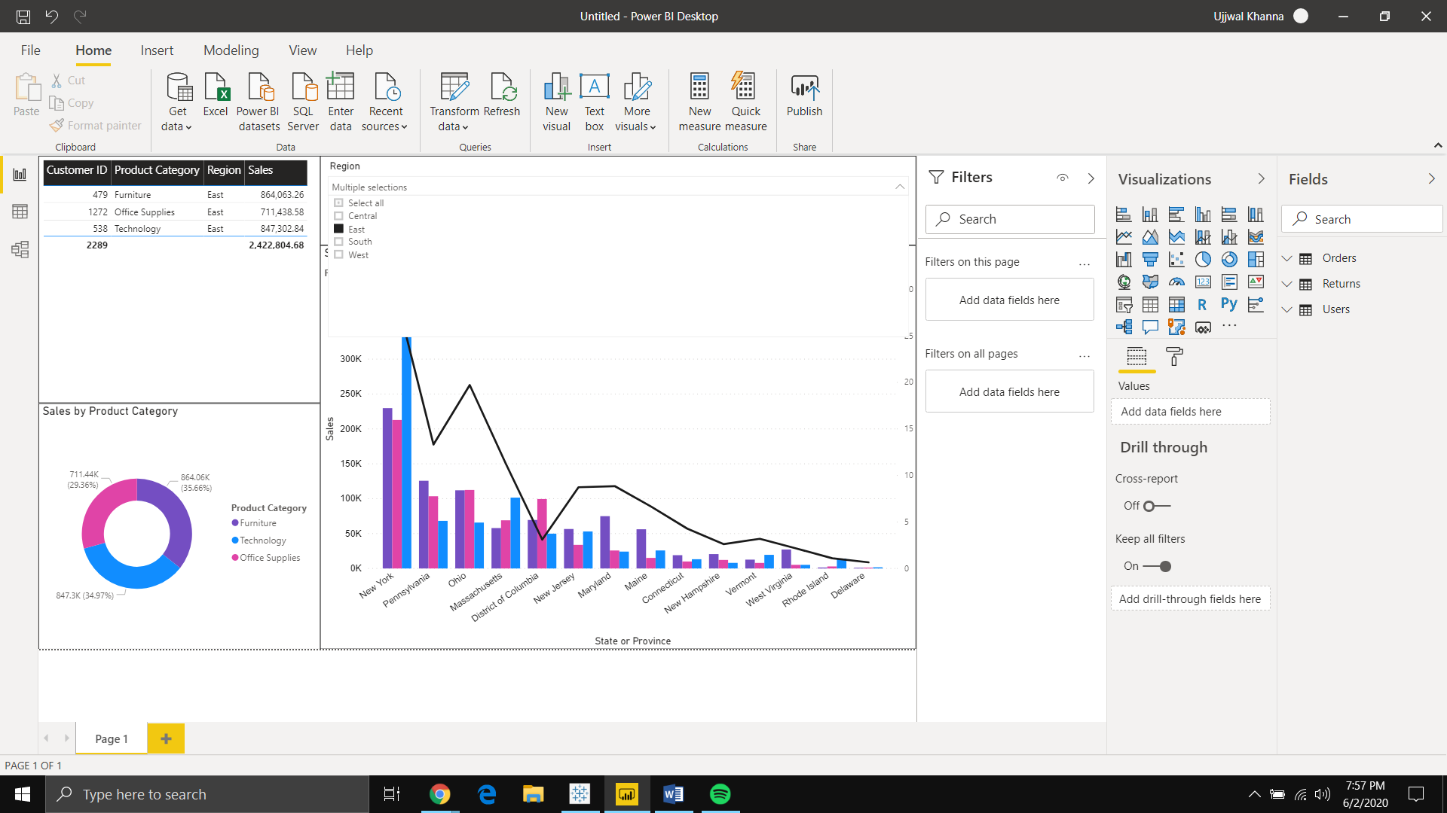

**South: -**

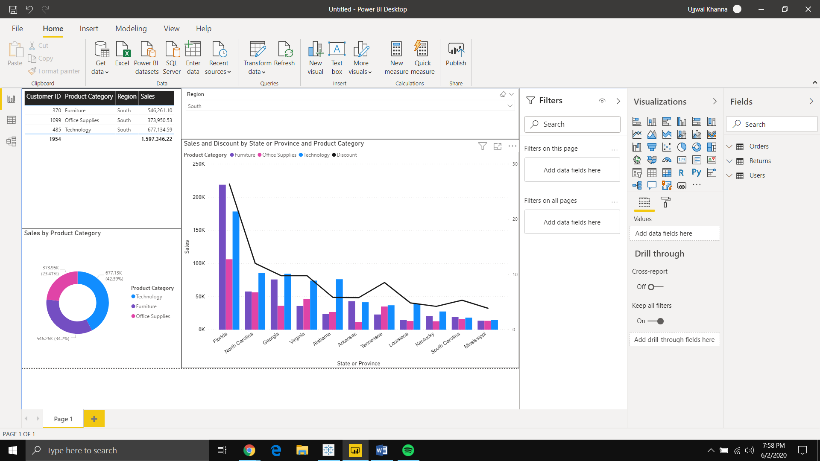

**West: -**

